Assignment 1 : CS-E4830 Kernel Methods in Machine

Yi Zhang 602466

**Question 1. If K is a positive semidefinite kernel matrix, then all its entries must be positive.**

**Answer:**

False, For example .,not all entries are positive.

**Question 2.**

**Answer:**

True, for any none-zero vector v:





as we know,



so



**Question 3**

**Answer:**

False, for example  K is not a valid kernel matrix.

**Parzen window classifier**

**Question 4**









and 

We define a vector 

 if y=+1



 if y=-1

Then it could be written as



**Question 5:**

**answer:**

**see the code “gauss_kernel.m”**

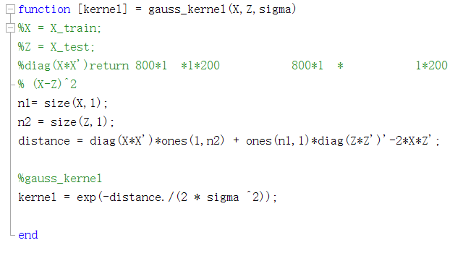

**Question 6:**

**see the code “h_func.m”**

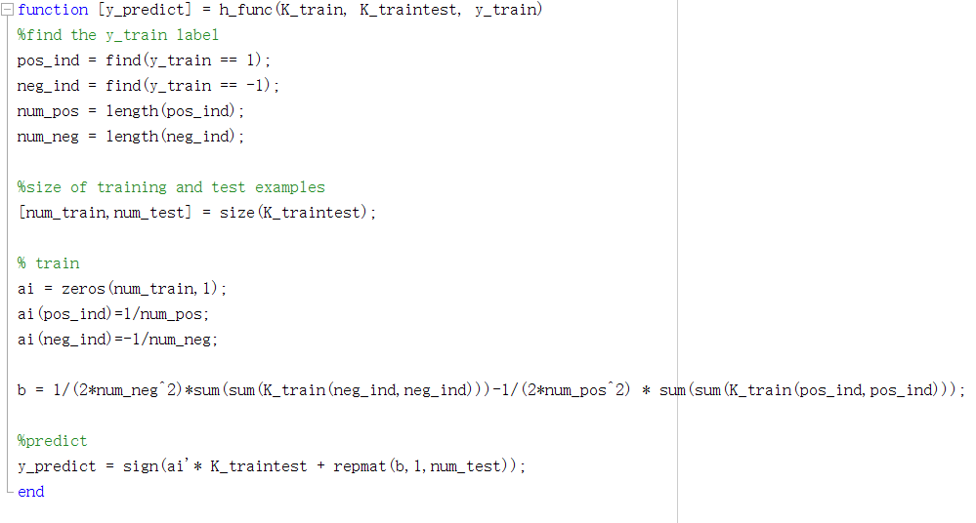

**Question 7**

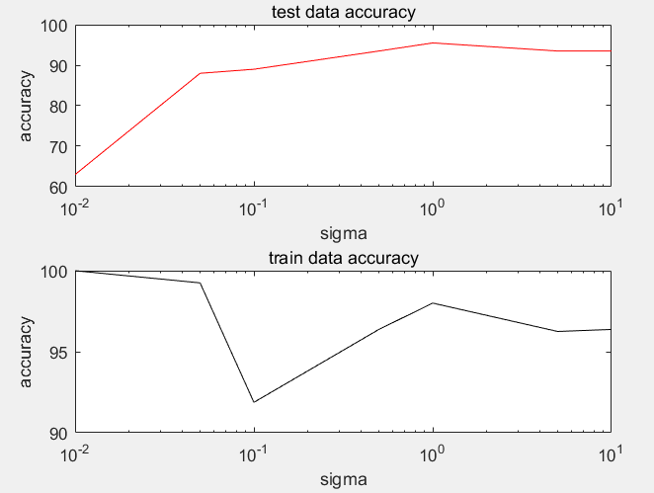

**Figure 1**

As we could see from the Figure1, in small sigma region, test accuracy is low and train data accuracy is high because of the overfitting, however, in big sigma region, the test accuracy is relatively large.